Assignment # 2
Data Structure and Algorithm Due: 27- Oct-2018

- Given an expression string exp , write a program to examine whether the pairs and the orders of “{“,”}”,”(“,”)”,”[“,”]” are correct in exp. For example, the program should print true for exp = “[()]{}{[()()]()}” and false for exp = “[(])”
- (Postfix notation) Postfix notation is a way of writing expressions without using parentheses. For example, the expression (1 + 2) * 3 would be written as 1 2 + 3 * . A postfix expression is evaluated using a stack. Scan a postfix expression from left to right. A variable or constant is pushed into the stack. When an operator is encountered, apply the operator with the top two operands in the stack and replace the two operands with the result. The following diagram shows how to evaluate 1 2 + 3 * .
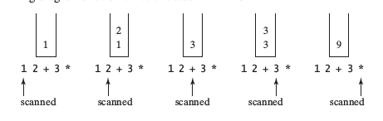

Write a program to evaluate postfix expressions. Pass the expression as a command-line argument in one string.
- (Convert infix to postfix) Write a method that converts an infix expression into a postfix expression using the following header:
public static String infixToPostfix(String expression)
For example, the method should convert the infix expression (1 + 2) * 3 to
1 2 + 3 * and 2 * (1 + 3) to 2 1 3 + * .

